**SECTION A (60 Marks)**

Answer only **three** questions from this section.

1. A compound, **T** contains carbon, hydrogen and nitrogen only. On complete combustion, **2.325g** of compound, **T** yielded **6.6g** of carbon dioxide gas and **295.4cm3** of nitrogen gas measured at a temperature of **15ᵒC** and pressure **760mmHg**.
2. Calculate the empirical formula of compound, T. (05 marks)
3. When compound was steam distilled at a temperature of **97ᵒC** and pressure of **755mmHg**, the distillate contained **45.49%** by mass of compound, T. [The saturated vapour pressure of water at this temperature **650mmHg**].Determine the molecular formula of compound,T. (03½ marks)
4. Compound, T burns with a sooty flame. Write the structural formula and name of compound, T. (01 mark)
5. When compound, T treated with a mixture of concentrated hydrochloric acid and sodium nitrite solution at a temperature below 5ᵒC, Compound, Z was formed. State what would be observed and write equation for the reaction when:
6. Compound, Z was warmed with acidified water. (02 marks)
7. An alkaline solution of Naphthalein-2-ol was added to Compound, Z. (02 marks)
8. Using equations only show how:
9. Compound, T is prepared from benzene. (03 marks)
10. Compound, Z can be converted to benzoic acid. (03 marks)
11. Write the formulae of the chlorides of group (IV) elements. (03½ marks)
12. State the condition (s) and write equation for the reaction to show the preparation of:
13. The chloride of carbon & silicon. (05 marks)
14. The chloride of lead. (05 marks)
15. Describe the reactions of chlorides of group elements with water. (06½ marks)
16. Define the terms: (@01 mark)
17. Conductivity.
18. Molar conductivity.

(b).The table below shows the molar conductivities of an aqueous sodium hydroxide solution.

|  |  |  |  |  |  |  |
| --- | --- | --- | --- | --- | --- | --- |
| Conductivity  mol/dm3 | 0.01 | 0.04 | 0.09 | 0.16 | 0.25 | 0.36 |
| Molar conductivity  Λ/Ωcm2/mol | 238 | 230 | 224 | 217 | 210 | 202 |

1. Plot a graph of molar conductivity against square root of conductivity. (03½ marks)
2. Use the graph to determine the molar conductivity of sodium hydroxide solution at infinite dilution. (01 mark)
3. Explain the shape of the graph. (03 marks)
4. (i) Draw a sketch graph to show the change in the conductivity with volume of ammonia solution when 25.0cm3 of 0.1M methanoic acid is titrated with 0.1M ammonia solution. (02 marks)
5. Explain the shape of the graph. (02 marks)
6. The conductivity of a saturated solution of silver phosphate at a room temperature is 2.661 x 10-6Scm-1 and that of pure water is 1.519 x 10-6Scm-1.If the molar ionic conductivities of silver and phosphate ions at infinite dilution at the same temperature are 61.9 and 240Scm2/mol respectively. Calculate the: (@02½ marks)
7. Solubility of silver phosphate in mol/dm3 at 25ᵒC.
8. Solubility product of silver phosphate at 25ᵒC and state its units.
9. (i) Define the term colligative property. (01 mark)
10. State the colligative properties of a solution. (02 marks)
11. (i) Describe how the molecular mass of cane sugar can be determined using one of the colligative properties. (06 marks)
12. State limitations of the methods used. (02 marks)
13. The table below shows the freezing points of various solutions of cane sugar in solvent X.The molar mass of cane sugar = 342g.

|  |  |  |  |  |  |  |  |
| --- | --- | --- | --- | --- | --- | --- | --- |
| Concentration (g/1,000g of solvent X) | 26.0 | 42.0 | 66.0 | 78.0 | 118.0 | 148.0 | 173.0 |
| Freezing point. (ᵒC) | 5.11 | 4.87 | 4.51 | 4.33 | 3.73 | 3.28 | 2.91 |

1. Plot a graph of osmotic freezing point against mass of cane sugar and use your graph to determine the: (03 marks)
2. Freezing point of solvent X. (01 mark)
3. Freezing point constant for solvent X. (02 marks)
4. State and explain how the freezing points of the solution would be affected if cane sugar associates in solution X. (03 marks)

**SECTION B (40 Marks)**

Answer only **two** questions from this section.

1. State:
2. Partition law. (01 mark)
3. Three limitations of the law. (01½ marks)
4. (i) Describe an experiment to determine the partition coefficient of phenol between ethoxyethane and water. (06 marks)
5. State two advantages and one demerit of using ethoxyethane in this experiment. (01½ marks)
6. An aqueous solution contains 10g of phenol per litre. When 100cm3 of this solution is shaken with 20cm3 of ethoxyethane, the ethoxyethane layer extracts 0.8g of phenol.Calculate the mass of phenol extracted when 500cm3 of the aqueous layer was shaken with: (@04 marks)
7. 50.0cm3 of the ethoxyethane.
8. Two successive 25.0cm3 portions of the ethoxyethane.
9. Comment on your results in (c) above. (02 marks)
10. Complete the following equations and write the suggested mechanism.



1. (a).Soap can be prepared from vegetable oil or animal fat.
2. Distinguish between vegetable oil and animal fat. (02 marks)
3. Briefly explain how vegetable oil can be extracted from a natural source. (03 marks)
4. (i) Briefly describe how soap can be prepared from a vegetable oil. State the chemical principles involved. (03½ marks) (ii)Write equation for the reaction leading to the formatting of soap. (01 mark)

(iii)State each one merit and demerit of using soap. (01 mark)

1. Briefly explain the cleaning action of soap. (02½ marks)
2. Explain why aqueous solution of soap is alkaline. (02 marks)
3. Distinguish between:
4. Soap and non-soapy detergent. (02 marks)
5. Starting from duodecane-1-ol write equations to show how you would prepare a detergent. (02 marks)
6. State each one merit and demerit of using a detergent in washing process. (02 marks)
7. Explain the following observations.
8. When hydrogen peroxide was added to lead (II) sulphide, black solid turned to white. (04 marks)
9. Beryllium oxide is insoluble in nitric acid but soluble in aqueous sodium hydroxide solution. (04 marks)
10. Carbonic acid [H2CO3] and sulphurous acid [H2SO3] are both weak acid but they exhibit different bond angles. (04 marks)
11. When aqueous ammonia solution was added to nickel (II) sulphate solution, green precipitate was formed which dissolved to form a blue solution. (04 marks)
12. When methanoic acid was warmed with Fehling’s solution, a red precipitate was formed whereas ethanoic acid, there was no observable change occurs. (04 marks)

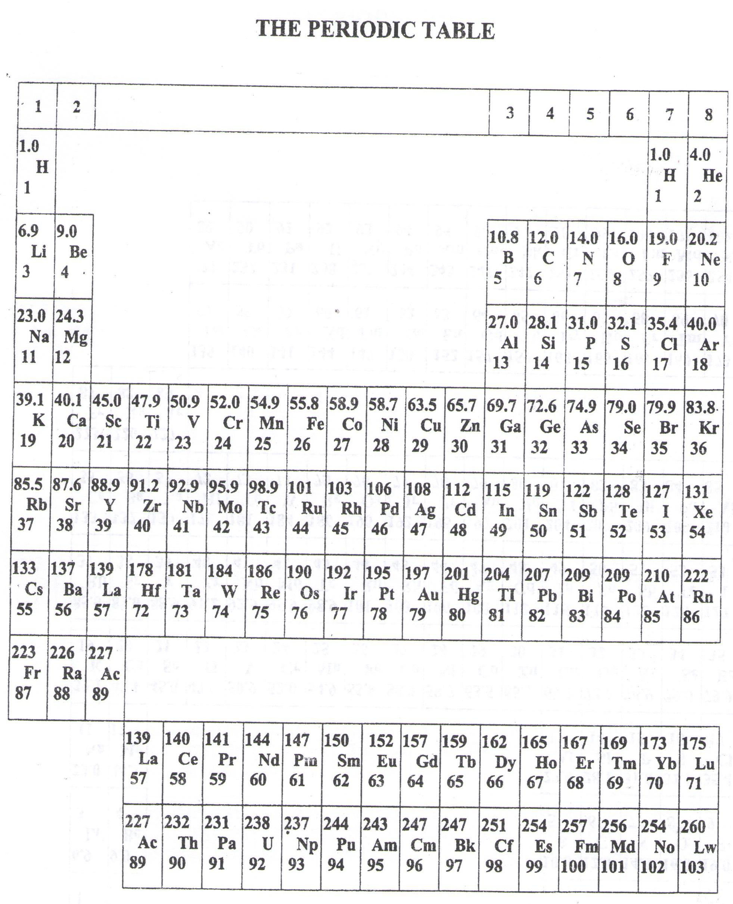

* ===END===

WELCOME TO SENIOR SIX, YEAR 2024

This is the last page of the printed paper, Page 06